1.EMPLOYEES EARNING MORE THAN THEIR MANAGERS

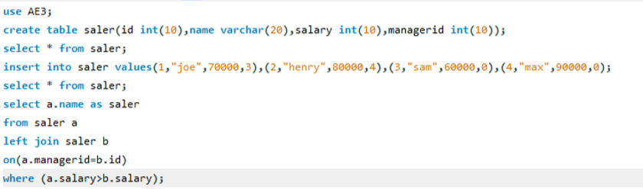

2. .FIND CUSTOMER REFEREE

